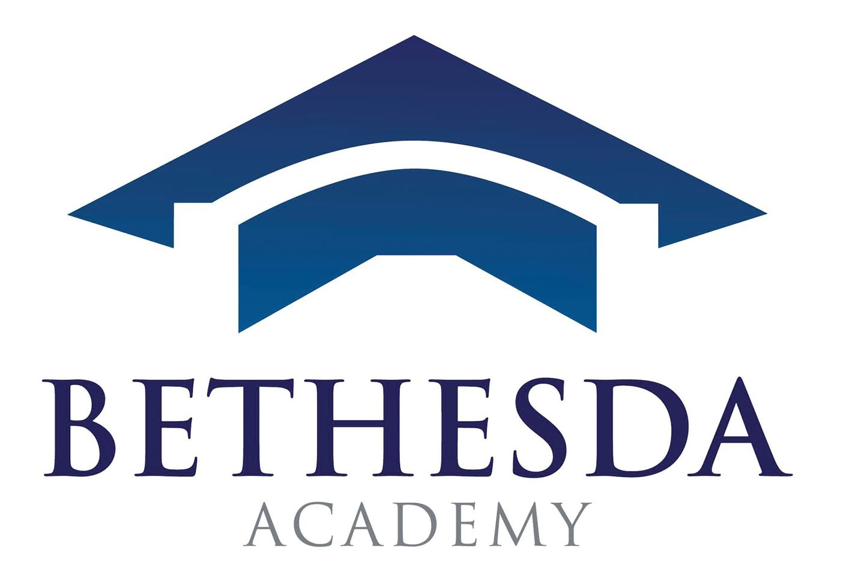
Welcome Back Blazers!
Can you believe that it is already time to re-enroll for the 2021-2022 school year? In preparation for next school year, please take the time now to complete the re-enrollment packet.
To complete the online re-enrollment process, you will need to access your RenWeb Parents Web and FACTS accounts through your existing logins.
To access Parents Web for the re-enrollment packet, please follow the instructions below:
- Go to www.renweb.com
- Select Logins from the menu bar and Parents Web Login from the drop-down menu
- Type in your existing username and password. If you have forgotten your username and/or password, please click on the ‘Forgot username or password’ link
- Once logged in, click on apply/enroll, then enrollment/reenrollment, then click the blue link that states click here to open enrollment
- Submit the application and pay the $175 re-enrollment fee
To access the FACTS 2021-2022 Grant/Aid Application, please follow the instructions below:
- Go to https://online.factsmgt.com/signin/4DYLZ
- Follow the instructions listed on the FACTS webpage to complete your 2021-2022 Financial Aid Application and/or update your payment plan
- Upload your 2020 W2 and 1040 tax documentation to your financial aid application
- Submit the application and pay the $35 application fee
The process should take about 30 minutes to complete. Your information will be saved if you need to quit and come back at a later time to complete.
All returning Bethesda Academy students must complete a RenWeb and FACTS Tuition Management Grant/Aid application to be considered for re-enrollment and to receive financial aid assistance from Bethesda Academy.
If you have any questions, please contact me at 912.351.2068 or Tia.Adkins@BethesdaAcademy.org.
Sincerely,
Tia Adkins
Director of Admissions

P.O. Box 13039 Savannah, GA 31416 www.BethesdaAcademy.org
A LOVE OF GOD A LOVE OF LEARNING A STRONG WORK ETHIC

